**## Demonstrate HTML assertions in JMeter**.

* It captures errors and warnings on the HTML page that jmeter connects to
* After which it can put those errors and warning in a file and save it.
* Create a Thread group 🡪 add sampler HTTP request

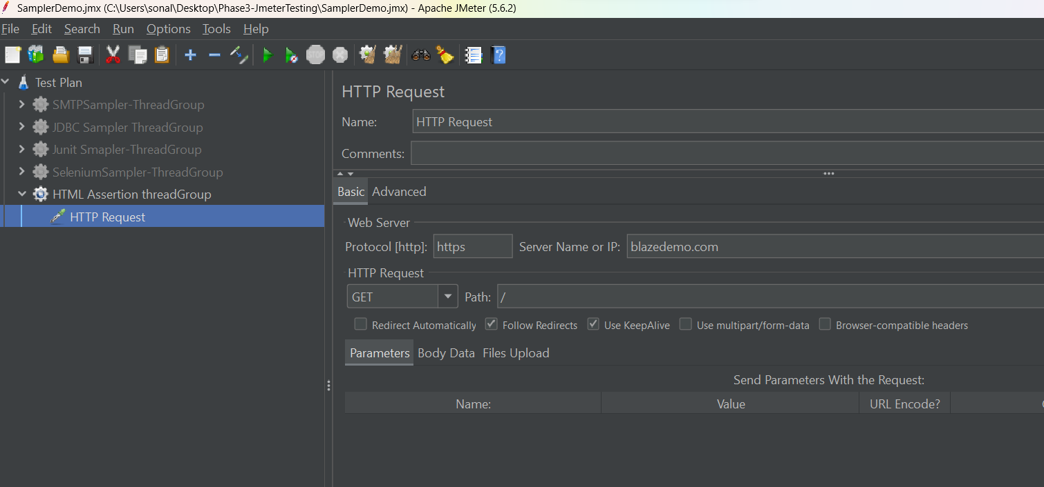

* Add HTMl assertion to http sampler

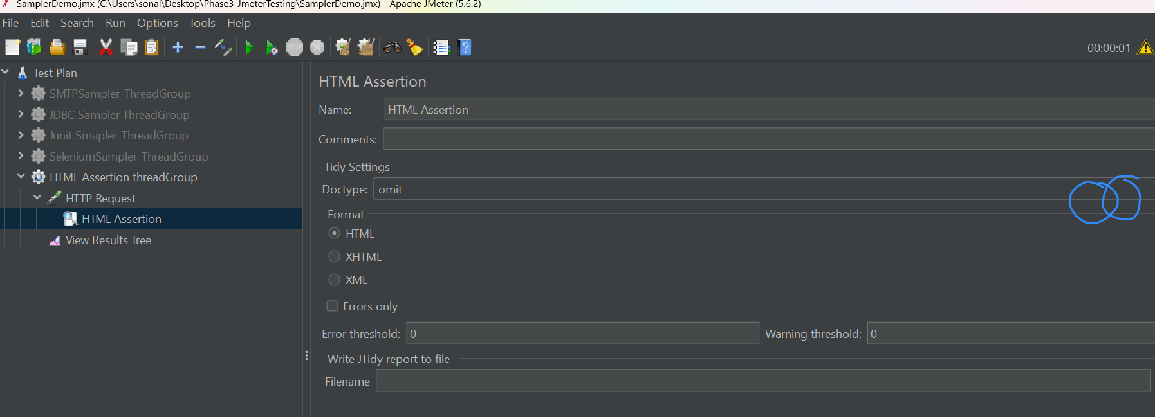

* Create a new folder using browser button, also give the file name at the same time

